TASK 6 Implement various text file operations.

6.a
In a famous tech firm, an employee is asked to copy the contents of N no.of files to another N no. of files. Fortunately, the employee has good knowledge in python scripting. So he plans to automate the copy operation by creating a copy function using python file handling operations. Assume you are that employee and implement the copy function to achieve the task.
Example:

Input:
‘Asdfghjk’

File 1: (write contents from input to file 1)
Asdfghjk
Output: (copy the contents of file 1 to file 2)
File 2:
Asdfghjk

PROGRAM

def copy_files(file_paths):
for file_path in file_paths:
if os.path.exists(file_path):
with open(file_path, 'r') as original_file:
original_content = original_file.read()
copy_file_path = file_path.split('.')[0] + '_copy.' + file_path.split('.')[1]
with open(copy_file_path, 'w') as copy_file:
copy_file.write(original_content)
print(f"Contents copied from {file_path} to {copy_file_path} successfully.")
else:
print(f"Error: File '{file_path}' not found.")

# Example usage:
import os
file_list = ['file1.txt', 'file2.txt', 'file3.txt'] # List of file paths
copy_files(file_list)

OUTPUT
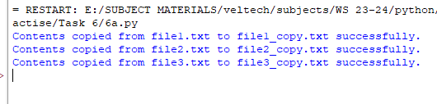


Problem 6.b:
You need to write a report containing the details (Name, departments) of the employee in list. Write a Python function that writes this report to a file named employee_report.txt
Algorithm:
- Create Employee Data:
  - Define the function write_employee_report(filename):
    - Create a list employees containing dictionaries, each with "name" and "department" keys for individual employees.
- Open File for Writing:
  - Open the file specified by filename in write mode using a with statement.
- Write Employee Data to File:
  - Loop through each employee in the employees list:
    - For each employee, format a string as "Name: {employee['name']}, Department: {employee['department']}".
    - Write the formatted string to the file, followed by a newline character (\n).
- Execute the Program:
  - Call write_employee_report("employee_report.txt") to write the employee data to the file "employee_report.txt".

Program 6.b:
def write_employee_report(filename):
employees = [
{"name": "Alice", "department": "HR"},
{"name": "Bob", "department": "Engineering"},
{"name": "Charlie", "department": "Finance"}
]

with open(filename, "w") as file:
for employee in employees:
line = f"Name: {employee['name']}, Department: {employee['department']}\n"
file.write(line)
# Example usage:
write_employee_report("employee_report.txt")

output:
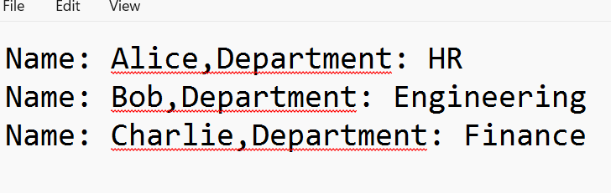

6.C.
A teacher wants to save student notes in a text file, display the content, and count how many times a chosen word appears. Write a Python program for this.
Sample Input and Output:
Enter the file name: student_notes.txt
Enter student notes (press Enter on an empty line to stop):
Python is fun
I love Python
Python Python Python
Coding in Python is great

File Content:
Python is fun
I love Python
Python Python Python
Coding in Python is great

Enter the word to count: Python

The word 'Python' occurs 6 times.

PROGRAM:
def teacher_notes_word_count():
# Step 1: Create a file and write student notes
file_name = input("Enter the file name: ")
with open(file_name, 'w') as file:
print("Enter student notes (press Enter on an empty line to stop):")
while True:
line = input()
if not line:
break
file.write(line + '\n')

# Step 2: Display the content of the file
print("\nFile Content:")
with open(file_name, 'r') as file:
content = file.read()
print(content)

# Step 3: Count occurrences of a chosen word
word = input("Enter the word to count: ")
count = content.split().count(word)
print(f"\nThe word '{word}' occurs {count} times.")

# Run the program
teacher_notes_word_count()

Output:
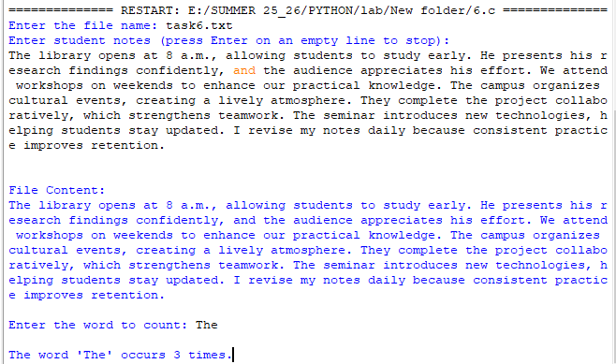

6.D.
A teacher wants to save student notes in a text file, display the content, and count how many times a chosen word appears. Write a Python program for this.
Sample Input and Output:
Enter CSV file name: data.csv
Student Records:
Id: 201, Name: John, Grade: A, Attendance: 92
Id: 202, Name: Linda, Grade: B, Attendance: 78
Id: 203, Name: Mark, Grade: C, Attendance: 85
Id: 204, Name: Susan, Grade: A, Attendance: 88
Id: 205, Name: Tom, Grade: B, Attendance: 90

Average Attendance: 86.60

students.csv

Id,Name,Grade,Attendance
101,Alice,A,90
102,Bob,B,85
103,Charlie,A,95
104,David,C,80
105,Eve,B,88

PROGRAM:
import csv

# Read CSV file
file_name = input("Enter CSV file name: ")
records = []

with open(file_name, 'r') as file:
reader = csv.reader(file)
next(reader) # Skip header
for row in reader:
records.append(row)

# Display all records
print("\nStudent Records:")
for r in records:
print(f"Id: {r[0]}, Name: {r[1]}, Grade: {r[2]}, Attendance: {r[3]}")

# Calculate average attendance
total = sum(int(r[3]) for r in records)
average = total / len(records)
print(f"\nAverage Attendance: {average:.2f}")

Output:
